Observation 59 – 13.1-create table

CREATE TABLE my_cd_collection(

cd_number NUMBER(3),

title VARCHAR2(20),

artist VARCHAR2(20),

purchase_date DATE DEFAULT SYSDATE

); 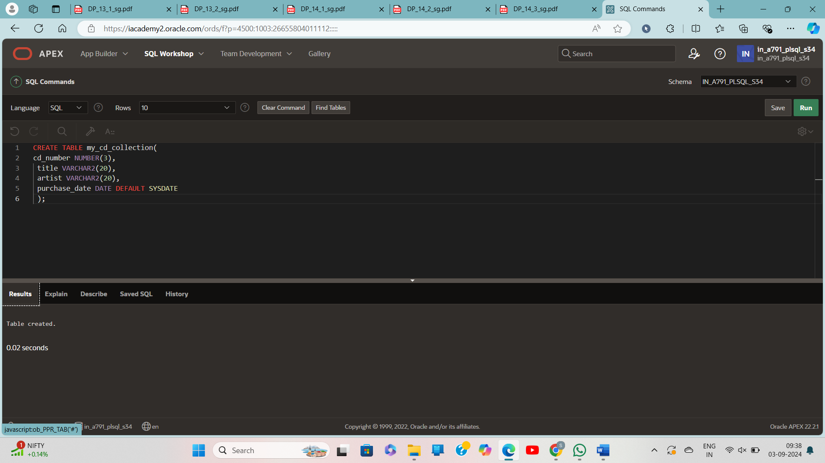

**13.2-timestamp**

CREATE TABLE time_ex1 (exact_time TIMESTAMP);

**Insert -----**

INSERT INTO time_ex1

VALUES ('10-Jun-2017 10:52:29.123456');

INSERT INTO time_ex1 VALUES (SYSDATE);

INSERT INTO time_ex1

VALUES (SYSTIMESTAMP);

SELECT * FROM time_ex1;

**13.2-time zone**

CREATE TABLE time_ex2

(time_with_offset TIMESTAMP WITH TIME ZONE);

INSERT INTO time_ex2 VALUES (SYSTIMESTAMP);

INSERT INTO time_ex2 VALUES ('10-Jun-2017 10:52:29.123456 AM +2:00');

SELECT * FROM time_ex2;

